|  |  |
| --- | --- |
| **Assignment Case** |  |
| COMP6048  Data Structures |
| **Computer Science** | **E213-COMP6048-KN01-01** |
| ***Valid on*** *Even Semester Year 2020/2021* | **Revision 00** |

1. Seluruh mahasiswa tidak diperkenankan untuk:

*All students are not allowed to:*

* + - Berdiskusi dan/atau bekerja sama dengan mahasiswa lainnya

*Discuss and/or work together with other student participants*

* + - Melihat sebagian atau seluruh jawaban mahasiswa lain

*Seeing a part or the whole answer from another student*

* + - Membuka dan menyalin dari **BUKU** atau **CATATAN**, **VIDEO** dari pengajar (recording kelas, VBL, Youtube, dsb) dan **REFERENSI** lainnya

*Open and copy from any resources such as notes, videos (class recording, VBL, Youtube, etc) and other references*

* + - Membuka dan menyalin jawaban dari internet (google, stackoverflow, dsb)

*Open and copy answer from the internet (google, stackoverflow, etc)*

* + - Mengerjakan soal yang tidak sesuai dengan tema yang ada di soal,

*Working with another theme which is not in accordance with the existing theme in the matter of the case,*

* + - Melakukan tindakan kecurangan lainnya,

*Committing other dishonest actions,*

* + - Secara sengaja maupun tidak sengaja melakukan segala tindakan kelalaian yang menyebabkan hasil karyanya berhasil dicontek oleh orang lain / kelompok lain.

*Accidentally or intentionally conduct any failure action that cause the results of the project was copied by someone else / other groups.*

1. Jika mahasiswa terbukti melakukan tindakan seperti yang dijelaskan butir 1 di atas, maka **nilai mahasiswa** yang melakukan kecurangan (menyontek maupun dicontek) akan di – **NOL** – kan.

*If the student is proved to the actions described in point 1 above, the score of the student which committed dishonest acts (cheating or being cheated) will be “Zero”*

1. Perhatikan jadwal pengumpulan jawaban, segala jenis pengumpulan jawaban di luar jadwal tidak dilayani.

*Pay attention to the submission schedule, all kinds of submission outside the schedule will not be accepted*

1. Bila Anda tidak membaca peraturan ini, maka Anda dianggap telah membaca dan menyetujuinya

*If you have missed to read these regulations, so you are considered to have read and agreed on it*

1. Persentase penilaiaan untuk matakuliah ini adalah sebagai berikut:

*Marking percentage for this subject is described as follows:*

|  |  |
| --- | --- |
| **Tugas Mandiri**  *Assignment* | **UAP**  *Final Exam* |
| 40% | 60% |

1. Software yang digunakan pada matakuliah ini adalah sebagai berikut:

*Software will be used in this subject are described as follows:*

|  |
| --- |
| **Software**  *Software* |
| Dev-C++ 5.11 |

## Ekstensi file yang harus disertakan dalam pengumpulan tugas mandiri, dan uap untuk matakuliah ini adalah sebagai berikut:

*File extensions should be included in assignment and final exam collection for this subject are described as follows:*

|  |  |
| --- | --- |
| **Tugas Mandiri**  *Assignment* | **UAP**  *Final Exam* |
| CPP | CPP |

## Soal

*Case*

**Billionaires Distro**

**Billionaires Distro** is a famous distro in Jakarta. This shop is having difficulties in listing their products. To increase the efficiency in **Billionaires Distro,** you as a programmer in **Billionaires Distro** are asked to create a program that could organize the product data using **C Language** and **Chaining Hash Table** data structure.

* The program will **show** **all** **the cloth** and have **3 menus**:

1. Add New Cloth
2. Delete Cloth
3. Exit

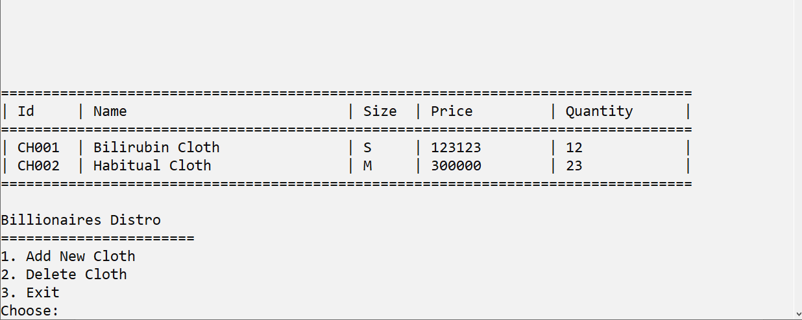

Figure 1. Main Menu with Cloth Data

* If there are no cloth yet or the list is empty, then the program **should show error message** “**No Cloth Yet**”.

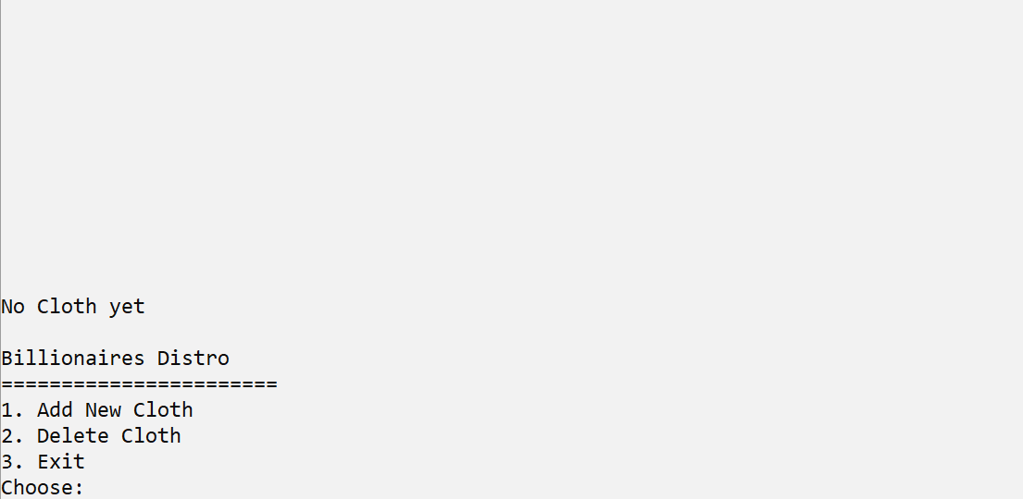

Figure 2. Main Menu with No Cloth Data

* If the user choose **menu 1** (**Insert New Cloth**), then:

1. The program will **generate the Cloth Id** for the inputted cloth data. The Cloth Id must follow the format below. The Id will be shown in the main menu if the cloth already inserted to the hash table:

CHXXX

XXX : the last 3 digits of the last cloth id added by 1

**Example**:

The last cloth id is CH003

Then the new generated cloth id is CH004

Figure 3. Cloth Id Format

1. The program will ask user to input the **name of cloth** and **validate** that the **name** must **between 6 and 20** characters.
2. The program will ask user to input the **cloth size** and **validate** that the **size** must be “**S**” or “**M**” or “**L**” (**case insensitive**).
3. The program will ask user to input the **cloth price** and **validate** that the **price** must be **between 100000 and 500000**.
4. The program will ask user to input the **cloth** **quantity** and **validate** that the **quantity** must be **more than 0.** Then user **will be directed back to the menu page**.

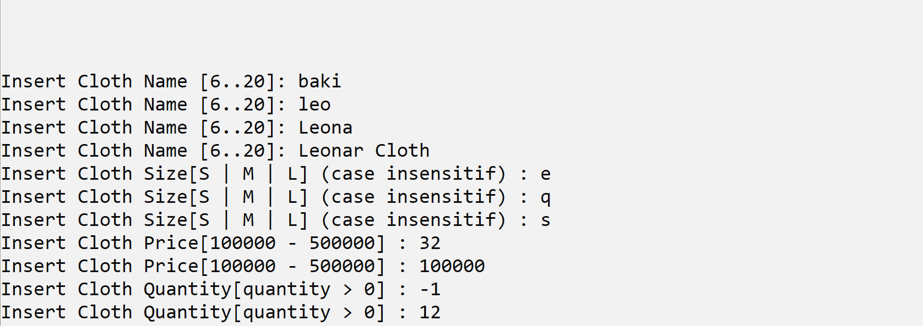

Figure 4. Input Validation

1. The program will **store new cloth data** to the **next item** of the **last item** of **chaining hash table** with **size** **99** using the following **hash function**.

Key = X % Y

Key : the hash table index that will store the data

X : the sum of each ascii character in the id

Y : size of the hash table (99)

**Example**:

Order Id : CH003

X : C (67) + H (72) + 0 (48) + 0 (48) + 3 (51) = 286

Size : 99

Key : 286 % 99

: 88

Then the cloth data will store at index 88 of hash table

Figure 5. Hash Function

* If the user choose **menu 2** (**Delete Cloth**), then:

1. The program will **show all the cloth list**. If there are **no cloth yet or the list is empty**, then the program should **show error message** “**No Cloth Yet**” and **redirect** user back to menu page.

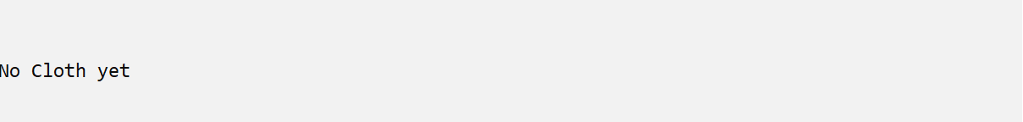

Figure 6. No Cloth Yet to Delete

1. Otherwise, the program will ask user to input the **cloth id to delete**.

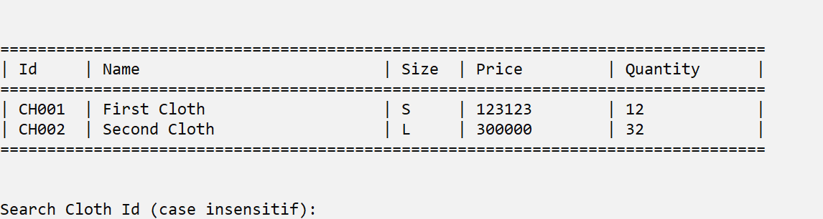

Figure 7. Input Cloth Id

1. The program will **search** for the **specified cloth (case insensitive)**.

* Validate the **cloth id must exists** (**case sensitive**).
* If the **Cloth id exists**, then:
  + The program will **remove** the **cloth data** from the **chaining hash table**
  + The program will **show** the **deleted cloth data**.

Figure 8. Delete Cloth (Id exists)

* If the user choose **menu 3** (**Exit**), then the program will **exit**.

**Please run the EXE file to get more detail about the application**